The CFWI Committee for Public Affairs presents:

WHy did you buy that?

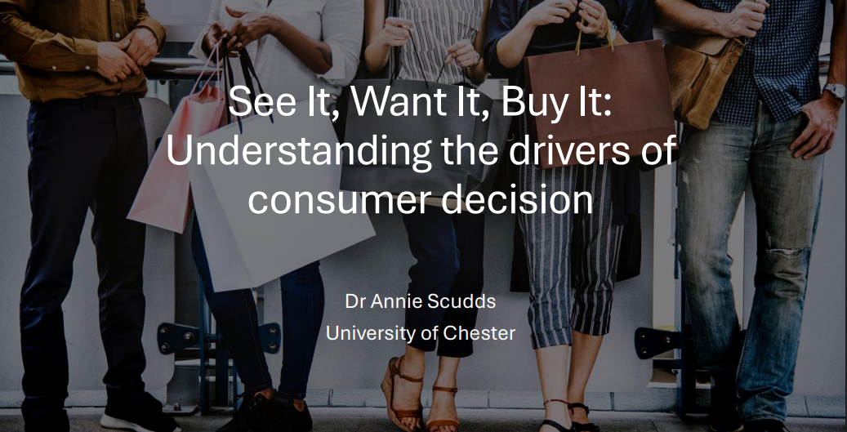
Wednesday 4th November 2026
Online Zoom seminar, 7pm – 8:15pm
No Charge
Dr Annie Scudds of the University of Chester is an experimental psychologist. Annie’s research has focused on the factors influencing people’s visual representations of their environment for most of her career. More specifically, Annie has had a particular focus on consumer packaging evaluation and its effect on people’s perception.

In this Zoom meeting Annie will show examples of how companies use their packaging to stand out, and how consumers use this information. She will also explain how product packaging influences our buying decisions, and the other factors that come into play when we are shopping.

In the run up to Christmas, this talk will give insight into the factors that influence customer decision making.

You never know- it might change the way you buy your Christmas Shopping this year!

