Malbank Spring Meeting 2026
Speaker Lucy Adlington
Tuesday 21st April 2026
Venue: The Function Room
at Nantwich Football Club
Start Time: 7.30pm

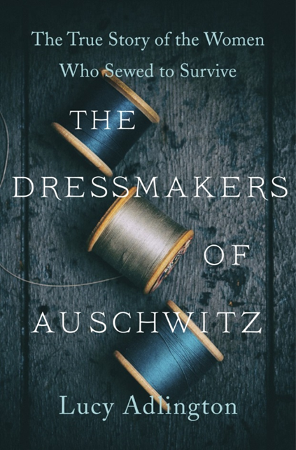
_{They sewed to survive…}
At the height of the Holocaust twenty-five young Jewish inmates of Auschwitz-Birkenau were selected to create beautiful fashions for elite Nazi women in a dedicated salon established by the camp commandant’s wife.
Historian Lucy Adlington has researched their lives and fates to write a powerful chronicle, The Dressmakers of Auschwitz, which became a New York Times bestseller.
This fascinating presentation, drawing on eyewitness interviews with original garments from the era, is a remarkable tale of resilience, camaraderie and quiet heroism in the most extreme circumstances.
Lucy Adlington is a writer and social historian, specialising in women's history in the 1940s.

