### CHESHIRE FEDERATION OF WOMEN'S INSTITUTES

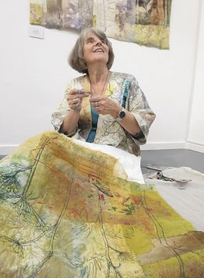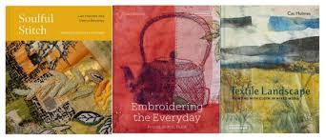

WI HOUSE. 11 WHITE FRIARS. CHESTER. CH1 1NZ email: [info@cheshirewi.org.uk](mailto:info@cheshirewi.org.uk)

#### The CFWI Sub-Committee for Art & Crafts presents:

A Zoom event with Cas Holmes

Tuesday 28th October 2025, 6.45pm for 7.00pm start.

# Cas Holmes

## Artist, Author, Tutor

Cas Holmes is an artist and writer of Romani descent and is one of the UK’s most renowned textile artists.

Trained in fine art, her work combines mixed media

with found materials and stitch and is best described as ‘painting with cloth’.

Join her in this Zoom presentation as she discusses her artistic practice and her life in stitch. Hear how she has shared her experiences and methods through her book, Embroidering the Everyday encouraging us all to look at our own environments and personal references for inspiration.

This event is for Cheshire WI members only.